Chatbot Conversations – Functional Documentation
Product: TrackIT
Channel: WhatsApp-like Two-Way Chatbot
Version: Draft

1. Overview
The Track IT Chatbot is a two-way conversational assistant integrated with the TrackIT application and delivered through a WhatsApp chat. The chatbot enables users to receive notifications, perform actions like create notes, create ticket(request) and query about tickets directly through chat.
2. Objectives
The objectives of the Chatbot within the Conversations module are:
- Act as a middleware for enabling communication between users and TrackIT
- Automate ticket creation, updates, notifications and deadline alerts
- Assist users with troubleshooting and system queries
- Capture only relevant chatbot interactions in TrackIT conversations
- Track progress of certain milestones, especially those meant for follow-ups, getting quotes and procurement and prompt user to close the milestone in progress
- Adding notes via chatbot for a ticket

3. Chatbot Scope
Chatbot conversations include only important, actionable, and application-relevant interactions and queries, such as:
- Core Conversational Capabilities
- Ticket creation
- Milestone Status and User Tagging Notifications
- Milestone status and tagging notifications
- Ticket Related Querying
- Assignment notification followed by acceptance prompts
- Conversation Logging in TrackIt
- Milestone related activity detection, tracking and suggested actions
- Notes management

4. Core Conversational Capabilities
4.1 Two-Way Communication
- Users can chat with the chatbot like a WhatsApp contact
- The chatbot both:
  - Sends notifications
  - Accepts commands and performs actions in TrackIT like creating a ticket adding note etc.

5. Ticket Creation via Chatbot
5.1 Assisted Ticket Opening
- User initiates conversation with the chatbot and is presented with three options Ask Queries, Add notes, Create Request.
  - The user clicks on Create Request option.
- Chatbot prompts the user for title and description.
- The user enters the ticket details thus creating the ticket in TrackIt.
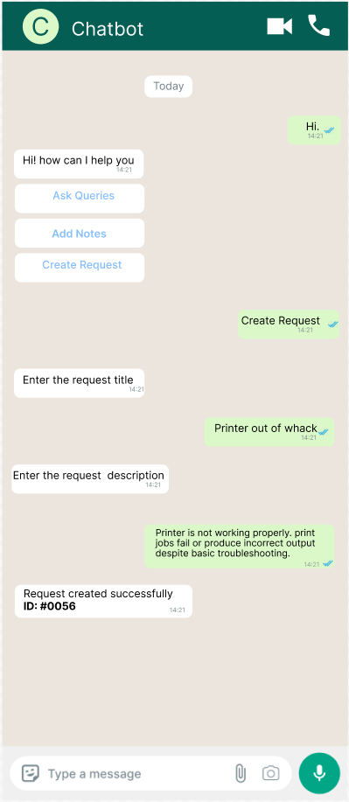

5.2 Probing-Based Ticket Creation (subject to R&D)
- If the user describes an issue in detail:
  - Chatbot probes with follow-up questions
  - Attempts resolution
- If unresolved:
  - Chatbot opens the ticket by getting the description on behalf of the user

6. Milestone Status and User Tagging Notifications
6.1 User Mentions in Notes
- If a specific user is mentioned in ticket notes:
  - Chatbot sends a WhatsApp notification to the mentioned user

6.2 Ticket and Milestone Updates
- Chatbot notifies all relevant stakeholders when:
  - A milestone is opened
  - A ticket is closed
  - Significant ticket updates occur
6.3 Milestone Deadline Alerts
- Chatbot sends proactive alerts when milestone deadlines approach
- Alert intervals:
  - T-24 hours
  - T-12 hours
  - T-1 hour
  - T-15 minutes
  - T-5 minutes
- Chatbot prompts the user to act

7. Ticket Related Querying
- User can ask the chatbot for ticket status
- Chatbot responds with:
  - List of all open ticket IDs associated with the user
- User selects a ticket to view:
  - Status
  - Ticket details
  - All Milestones
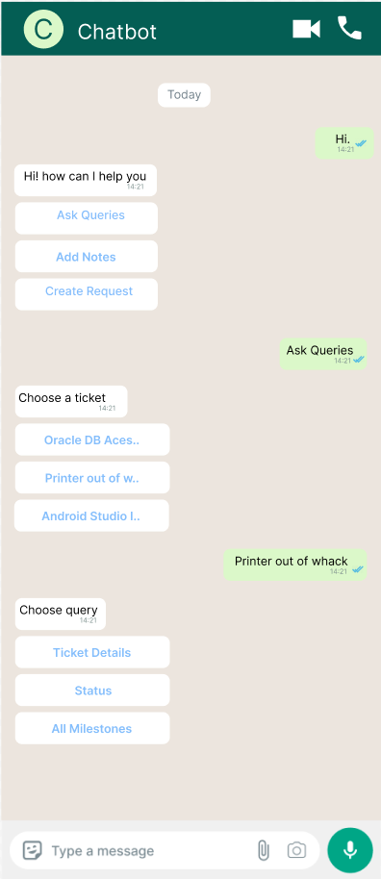

8. Assignment and Acceptance Flow
- When a ticket is assigned to a user by IT Admin:
  - Chatbot notifies the user and prompts him to accept the ticket
  - Provides a redirect link to the TrackIT app

9. Conversation Logging in TrackIT
9.1 Chatbot Section under Conversation Module
- TrackIT Chatbot section under Conversations tab contains:

  - Only specific chatbot interactions that are relevant to the ticket

  - Notes created via chatbot
9.2 Exclusions
- Entire chat history between users is not stored
- Only significant chatbot-driven events are recorded

10. Milestone related Activity Detection, Tracking and Suggested Actions
10.1 Call-Based Follow-Up Detection
- Chatbot detects phone calls (both incoming as well as outgoing) linked to follow-ups
If call duration exceeds 12 seconds:
  - If the chatbot reckons that a follow-up is complete, then it prompts the user to close :
    - Follow-up milestone
    - Or simple milestone e.g. A milestone has vendor details and if the chatbot detects a phone call with the vendor registered phone number then it prompts the user to close the milestone.
- Chatbot also tracks activities related to milestones for getting quotes or those for procuring new items. It keeps a track of incoming mails, especially those from the vendors listed on the milestone and prompts the user to update the milestone status.

11. Notes Management via Chatbot
11.1 Add Notes Feature
- Users can ask the chatbot to add notes
- Chatbot:
  - Displays all open tickets associated with the user and asks user to select a ticket and type the note
  - Adds the note to the selected ticket

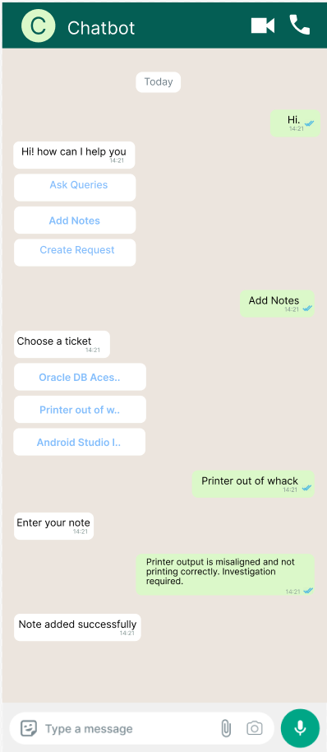

11.2 Chatbot Notes Characteristics
- Notes added via chatbot:
  - Appear under Chatbot section under the Conversations module
  - Are exclusive to chatbot interactions
  - Are separate from standard app notes

11.3 Recall and Edit Chatbot Notes (subject to R&D)
- Notes can be:
  - Edited by editing the associated WA message
  - Deleted by deleting the associated WA message
Both operations are allowed within 15 minutes from the creation of that note. This feature is subject to further research and validation.

12. Summary
The Chatbot Conversations module acts as a centralized, intelligent communication layer between users and the TrackIT application. By focusing on meaningful interactions, proactive notifications, and actionable prompts, the chatbot enhances productivity while maintaining a clean and relevant conversation record within TrackIT.

